Exercise 1:
ALPHABET = "abcdefghijklmnopqrstuvwxyz"
def encrypt(plain_text, shift_key):
plain_text = plain_text.lower()
cipher_text = ""
for char in plain_text:
if char in ALPHABET:
char_position = ALPHABET.index(char)
key_val = (shift_key + char_position) % 26
replace_val = ALPHABET[key_val]
cipher_text += replace_val
else:
cipher_text += char
return cipher_text
def decrypt(cipher_text, shift_key):
cipher_text = cipher_text.lower()
plain_text = ""
for char in cipher_text:
if char in ALPHABET:
char_position = ALPHABET.index(char)
key_val = (char_position - shift_key) % 26
replace_val = ALPHABET[key_val]
plain_text += replace_val
else:
plain_text += char
return plain_text
def main():
message = input("Enter the Plaintext for Encryption: ")
shift = 3
encrypted = encrypt(message, shift)
decrypted = decrypt(encrypted, shift)
print(f"\nEncrypted message: CipherText = {encrypted}")
print(f"Decrypted message: Plain Text = {decrypted}")
if __name__ == "__main__":
main()

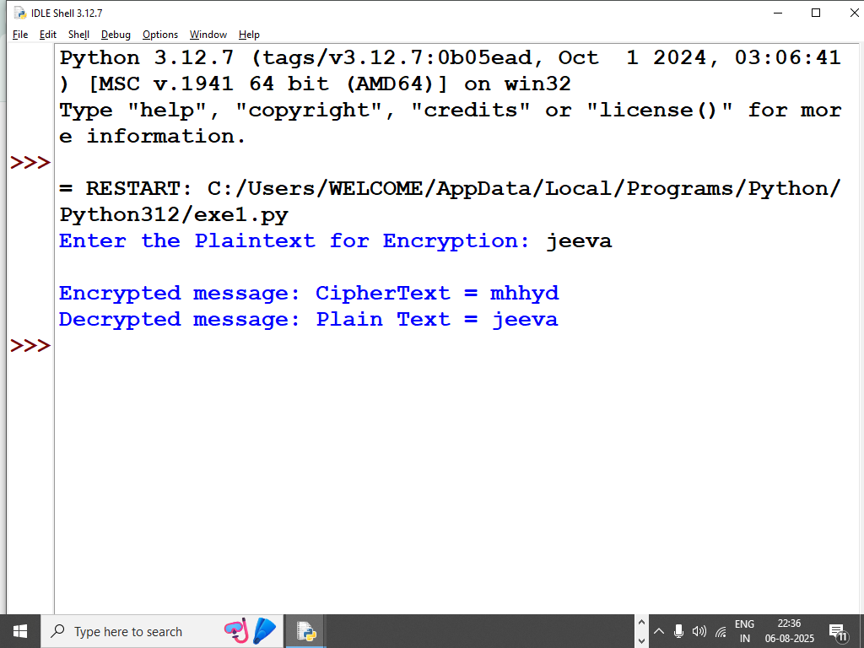

1) Constant
- ALPHABET = "abcdefghijklmnopqrstuvwxyz"
A lookup string that gives each lowercase letter a position (a→0, b→1, …, z→25).

2) encrypt(plain_text, shift_key)
- plain_text = plain_text.lower()
Normalize everything to lowercase so we only deal with ALPHABET.
- cipher_text = ""
Start with an empty result string.
- Loop: for char in plain_text:
Examine the message one character at a time.
- If the character is a letter (if char in ALPHABET:):
  - Find its index: char_position = ALPHABET.index(char)
e.g., 'c' → 2.
  - Shift it: key_val = (shift_key + char_position) % 26
Adds the key and wraps around with % 26 so after z we go back to a.
Example: shifting 'y' (24) by 5 → (24+5)%26 = 3 → 'd'.
  - Get the new letter: replace_val = ALPHABET[key_val].
  - Append it: cipher_text += replace_val.
- Else (space, punctuation, digits, etc.):
  - Keep it unchanged: cipher_text += char.
- Return the encrypted text: return cipher_text.

3) decrypt(cipher_text, shift_key)
This reverses the process.
- Lowercase the input: cipher_text = cipher_text.lower().
- plain_text = "" to build the result.
- Loop through each char in cipher_text.
- If it’s a letter:
  - Find its index: char_position = ALPHABET.index(char).
  - Reverse the shift: key_val = (char_position - shift_key) % 26.
Example: decrypt 'd' (3) with key 5 → (3-5)%26 = 24 → 'y'.
  - Map back to a letter: replace_val = ALPHABET[key_val].
  - Append to plain_text.
- Else: append the character unchanged.
- Return the decrypted text.

4) main()
- message = input("Enter the Plaintext for Encryption: ")
Ask the user for a message.
- shift = 3
Use a Caesar shift of 3 (classic setting). You can change this number.
- encrypted = encrypt(message, shift)
Produce the ciphertext.
- decrypted = decrypt(encrypted, shift)
Immediately decrypt it back to verify.
- Print results using f-strings.

5) Module guard
if __name__ == "__main__":
main()
This runs main() only when the file is executed directly (not when imported as a module).

6) Quick example
Input: Hello, World! with shift 3
- Encrypt: khoor, zruog!
- Decrypt (back): hello, world!

Notes & tips
- Non-letters (spaces, punctuation, digits) are preserved.
- Everything is forced to lowercase, so uppercase letters become lowercase in output.
(If you want to preserve case, you’d need a small tweak to handle uppercase separately.)
- The % 26 ensures wrap-around, so any shift (even large or negative) still maps into 0–25 correctly.

1.d
def generate_key(message, key):
key = key.upper()
key = list(key)
if len(message) == len(key):
return "".join(key)
else:
for i in range(len(message) - len(key)):
key.append(key[i % len(key)])
return "".join(key)

def encrypt(message, key):
message = message.upper()
key = generate_key(message, key)
cipher_text = ""
for i in range(len(message)):
if message[i].isalpha():
x = (ord(message[i]) + ord(key[i])) % 26
x += ord('A')
cipher_text += chr(x)
else:
cipher_text += message[i]
return cipher_text

def decrypt(cipher_text, key):
key = generate_key(cipher_text, key)
original_text = ""
for i in range(len(cipher_text)):
if cipher_text[i].isalpha():
x = (ord(cipher_text[i]) - ord(key[i]) + 26) % 26
x += ord('A')
original_text += chr(x)
else:
original_text += cipher_text[i]
return original_text

def main():
key = input("Enter the key: ")
message = input("Enter the message for encryption: ")
encrypted = encrypt(message, key)
decrypted = decrypt(encrypted, key)

print("\nOriginal Message:", message)
print("Encrypted Message:", encrypted)
print("Decrypted Message:", decrypted)

if __name__ == "__main__":
main()

output:
Enter the key: jeeva
Enter the message for encryption: artificial
Original Message: artificial
Encrypted Message: JVXDFRGMVL
Decrypted Message: ARTIFICIAL

Step 1 — Setup
Message:
H E L L O
Key (repeated to match length of message):K E Y K E

Why repeat the key?
Because the cipher uses the key letter to decide how far to shift each message letter. If the message is longer than the key, we cycle the key’s letters.

Step 2 — Convert letters to numbers
We give each letter a number (A=0, B=1, C=2 … Z=25):
Message:
H = 7
E = 4
L = 11
L = 11
O = 14

Key:
K = 10
E = 4
Y = 24
K = 10
E = 4

Step 3 — Encryption formulaVigenère encryption uses:

Encrypted number = (Message number + Key number) mod 26

Now apply it:

H (7) + K (10) = 17 → R

E (4) + E (4) = 8 → I

L (11) + Y (24) = 35 → 35 mod 26 = 9 → J

L (11) + K (10) = 21 → V

O (14) + E (4) = 18 → S

Step 4 — Result

Encrypted text:RIJVS

So the process is just:
Repeat the key until it matches the message length.
Convert both to numbers (A=0 → Z=25).

Add message number + key number, wrap with % 26.
Convert back to letters.

If you want, I can also show you the reverse (decryption) step-by-step for this same example so you see how we get HELLO back from RIJVS. Would you like me to do that?

1.b
def generate_matrix(key):
key = key.upper().replace('J', 'I')
seen = set()
matrix = []

# Add unique characters from the key
for char in key:
if char not in seen and char.isalpha():
seen.add(char)
matrix.append(char)

# Add remaining letters of alphabet (excluding J)
for char in "ABCDEFGHIKLMNOPQRSTUVWXYZ":
if char not in seen:
seen.add(char)
matrix.append(char)

# Convert flat list into 5x5 matrix
return [matrix[i*5:(i+1)*5] for i in range(5)]

def find_position(matrix, char):
for i in range(5):
for j in range(5):
if matrix[i][j] == char:
return i, j
return None

def format_message(msg):
msg = msg.upper().replace('J', 'I').replace(' ', '')
formatted = ''
i = 0

while i < len(msg):
char1 = msg[i]
if i + 1 < len(msg):
char2 = msg[i+1]
if char1 == char2:
formatted += char1 + 'X'
i += 1
else:
formatted += char1 + char2
i += 2
else:
formatted += char1 + 'X'
i += 1

return formatted

def encrypt_pair(matrix, a, b):
row1, col1 = find_position(matrix, a)
row2, col2 = find_position(matrix, b)

if row1 == row2: # Same row
return matrix[row1][(col1+1) % 5] + matrix[row2][(col2+1) % 5]
elif col1 == col2: # Same column
return matrix[(row1+1) % 5][col1] + matrix[(row2+1) % 5][col2]
else: # Rectangle rule
return matrix[row1][col2] + matrix[row2][col1]

def decrypt_pair(matrix, a, b):
row1, col1 = find_position(matrix, a)
row2, col2 = find_position(matrix, b)

if row1 == row2: # Same row
return matrix[row1][(col1-1) % 5] + matrix[row2][(col2-1) % 5]
elif col1 == col2: # Same column
return matrix[(row1-1) % 5][col1] + matrix[(row2-1) % 5][col2]
else: # Rectangle rule
return matrix[row1][col2] + matrix[row2][col1]

def playfair_encrypt(msg, key):
matrix = generate_matrix(key)
msg = format_message(msg)
encrypted = ''
for i in range(0, len(msg), 2):
encrypted += encrypt_pair(matrix, msg[i], msg[i+1])
return encrypted

def playfair_decrypt(cipher, key):
matrix = generate_matrix(key)
decrypted = ''
for i in range(0, len(cipher), 2):
decrypted += decrypt_pair(matrix, cipher[i], cipher[i+1])
return decrypted

def print_matrix(matrix):
print("Playfair Matrix:")
for row in matrix:
print(" ".join(row))
print()

def main():
key = input("Enter keyword: ")
msg = input("Enter message to encrypt: ")

matrix = generate_matrix(key)
print_matrix(matrix)

encrypted = playfair_encrypt(msg, key)
print("Encrypted message:", encrypted)

decrypted = playfair_decrypt(encrypted, key)
print("Decrypted message:", decrypted)

if __name__ == "__main__":
main()

output:

OUTPUT:
PlayfairMatrix:
MONAR C H Y B D E F G I K
L P Q S T UVWXZ

Encrypted message: GATLMZCLRQTX Decryptedmessage:INSTRUMENTSX

1.c
import numpy as np

# 3x3 Hill Cipher Key Matrix
key_matrix = np.array([
[1, 2, 1],
[2, 3, 2],
[2, 2, 1]
])

# Inverse of the above key matrix (mod 26)
inv_key_matrix = np.array([
[-1, 0, 1],
[2, -1, 0],
[-2, 2, -1]
])

alphabet = "ABCDEFGHIJKLMNOPQRSTUVWXYZ"

def mod26(n):
return n % 26 if n >= 0 else (26 + n % 26)

def text_to_vector(text):
return [ord(char) - 65 for char in text]

def vector_to_text(vec):
return ''.join([alphabet[mod26(num)] for num in vec])

def encrypt_block(block):
vec = text_to_vector(block)
result = np.dot(key_matrix, vec) % 26
return vector_to_text(result)

def decrypt_block(block):
vec = text_to_vector(block)
result = np.dot(inv_key_matrix, vec)
result = [mod26(round(x)) for x in result] # ensure integers mod 26
return vector_to_text(result)

def prepare_text(text):
text = text.upper().replace(" ", "")
while len(text) % 3 != 0: # pad with X if not multiple of 3
text += 'X'
return text

def main():
text = input("Enter the Plaintext for Encryption: ")
text = prepare_text(text)
print("Padded Text:", text)

encrypted = ''
for i in range(0, len(text), 3):
encrypted += encrypt_block(text[i:i+3])
print("Encrypted Message:", encrypted)

decrypted = ''
for i in range(0, len(encrypted), 3):
decrypted += decrypt_block(encrypted[i:i+3])
print("Decrypted Message:", decrypted)

if __name__ == "__main__":
main()

SAMPLEINPUT:
EnterthePlaintextforEncryption:ACT

SAMPLEOUTPUT:
PaddedText:ACT
Encrypted Message: GYO DecryptedMessage:ACT

